The Contemporary Condition

Tuesday, July 6, 2010

Is BP an Environmental Terrorist?
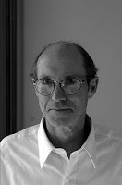
John Buell
Author of Evil Doers: Demonization and the End of Civil Debate in American Politics (NYU Press)
“Extremist Muslims” here and abroad are readily suspected of violent acts, termed terrorists, and denied minimal rights. BP, however, is treated as a person entitled to full protection of the law. Even in the event of an indictment, BP need not worry about the status of its Miranda rights or its ability to mount the best defense money can buy. Both Faisal Shazhad and BP should be indicted and given fair trials, but crime and terrorism, like all central political concepts, have complex baggage, carry limits, and should start a wider debate. Why are BP executives not designated as environmental terrorists? Corporate PR often brands nonviolent opponents of ecologically destructive mining, drilling, and forestry practices ecoterrorists. The term however, better fits BP’s behavior. Even had Shahzad succeeded in his plot, far fewer would have died than will perish from the Gulf oil eruption. Toxic fumes are already disabling some clean up workers and over many years pollutants will take many of our youngest or most vulnerable.
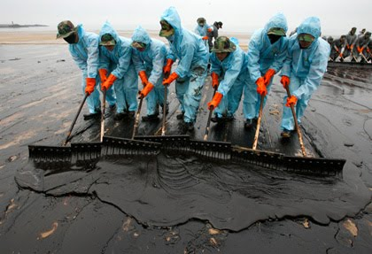
Since BP did not intend such a catastrophe, shouldn’t it be exonerated? As Rand Paul says, accidents just happen. Nonetheless, because accidents do happen, corporations are obligated to avoid riskiest sites, to maintain all possible means of accident remediation, and to follow strict precautions. This company knowingly violated vital regulations. It risked countless lives for the sake of economic power. It has a history of retaliation against internal whistleblowers. Even now it prohibits its temporary cleanup crew from bringing their own respirators as protection from toxic fumes. In defiance of an EPA request, BP spreads a dispersant banned in Europe. It major goal, says one environmental writer, is “to hide the body.”
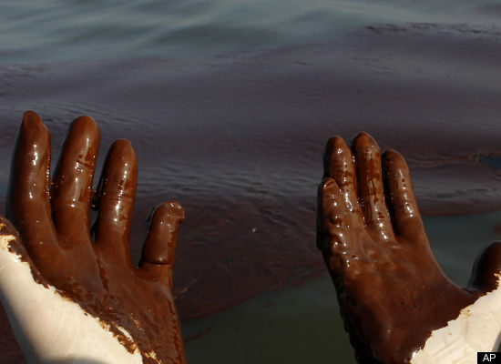
Despite a reckless past and inept and highhanded management of the current crisis, the company continues to call the shots. By spending a mere four percent of its profits on alternative energy BP rebranded itself as a can-do corporate friend of both economic growth and the environment.
If BP were owned by the Taliban, however, its every past deed, ad, and utterance would be scrutinized and ridiculed. Religiously and often ethnically different from the US mainstream Moslems here and abroad are often automatically cast in one light. Some of our religious leaders charge that Islam is fundamentally a violent religion. These extremist Christians have a language and rhetorical style that often resembles that of the radical Islamists. Pat Robertson doesn’t speak for all US Christians, but his views always command a hearing.
The sacred texts and sects of Islam, like those of Christianity, include some violent rhetoric and violence- prone agendas, though the bulk of both traditions condemns violence. Even Islam’s most rhetorically violent sects, as with the Christian right, have varying targets and don’t always resort to violence. Nonetheless, those political and media figures that are willing to acknowledge Islam’s divergent currents still often paint any Muslim cleric who criticizes the US with the same brush.
They “hate us for our freedom” and seek to destroy us, as President Bush says. Portraying those who oppose our policy even rhetorically as vicious and out to destroy our way of life, itself a concept ill defined by Bush, may reassure us as to the worth of our own values and policies and give us a sense of purpose. It does, however, play upon and reinforce an attitude toward US Arabs that long antedated 9/11. Bush I, Bush II, and Obama have all taken very different conflicts as an occasion to present war as an opportunity to fashion and restore a proud, enduring identity that would match or exceed that of an idealized WWII generation. Here is Obama’s take: “Now this generation faces a great test in the specter of terrorism. And unlike the Civil War or World War II, we can't count on a surrender ceremony to bring this journey to an end. Right now, in distant training camps and in crowded cities, there are people plotting to take American lives. That will be the case a year from now, five years from now, and -- in all probability -- 10 years from now.” Obama’s apparent pessimism is laced with a hidden sugar coating, the promise of an enduring purpose, something many Americans now find lacking in turbulent times and for which they feel a desperate need.
Radical Islamists have not of course attacked Sweden where cultural freedoms, especially for women, exceed our own. And just where, in what numbers or frequency, or why people are plotting to take American lives is hardly specified nor is evidence provided.
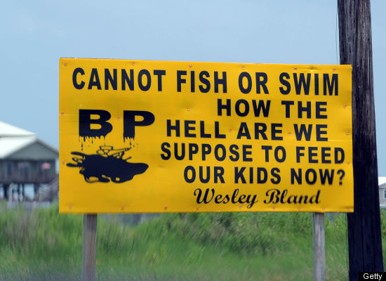
One careful study by the establishment- oriented Rand Corporation, little discussed by the mainstream media, suggests that domestic terrorism is grossly exaggerated. Rand pointed out: “…since September 11, 2001…the problem, while serious, was wildly overblown. There have been… 46 incidents of Americans or long-time U.S. residents being radicalized and attempting to commit acts of terror (most failing woefully) since 9/11. Those incidents involved… 125 people… about six cases of purported radicalization and terrorism a year…In comparison From January 1969 to April 1970 alone, the U.S. somehow managed to survive 4,330 bombings, 43 deaths, and $22 million of property damage.
If the rate of such attacks does increase, does this constitute proof that Taliban or Osama is stirring up US Muslims? Our political leaders seldom contemplate the possibility that US citizen terrorists like Shazhad might have been disturbed by US drone attacks on Pakistani or Afghan civilians rather than inspired by Taliban leaders. Despite some press reports about Shazhad’s anger regarding drone attacks, Obama’s top counterterrorism adviser, John Brennan, brushed such reports aside and insisted the suspect was“captured by the murderous rhetoric of Al Qaeda and TTP that looks at the United States as an enemy.”
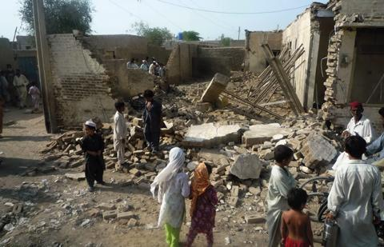
Perhaps closer scrutiny of the suspect’s own words isn’t needed if one doesn’t want to confront problematic aspects of our own ideals and actions.
Though BP has a full say in our media, we seldom hear Muslim extremists themselves. Even ordinary, nonpolitical Muslims who have contributed to our safety hardly receive a mention. Salisbury reminds us of:“Alioune Niass, the Sengalese Muslim vendor who first spotted the… smoking SUV…If it were not for the Times of London, we would not even know of his pivotal role in the story. No mainstream American newspaper bothered to mention…Niass,…”
Documenting Niass’s role might blunt prevalent monolithic stereotypes of Muslims and also plant the notion that getting the cooperation of minority communities is more effective in curbing violence than generalized surveillance or racial profiling.
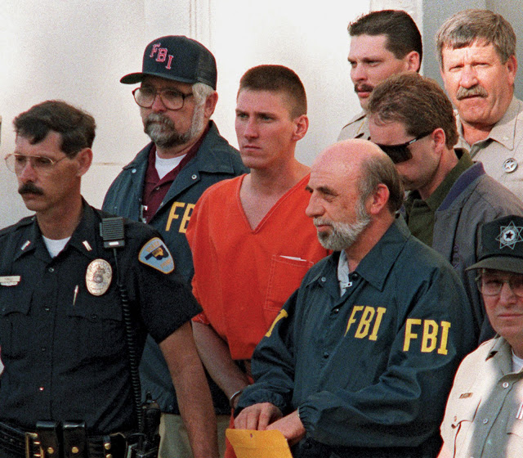
And when violence is wreaked on Muslims in this country, few mainstream media conclude that Americans are uniquely violent or dare suggest that Muslims too can be victims of terrorism. Pierre Tristam comments:“Few of you know that 10 days after the [incident] in Times Square, an actual terrorist attack took place in Jacksonville when a firebomb exploded outside the city's biggest mosque,… 60 worshippers were praying inside when the bomb went off… The bomber is still at large. The Jacksonville Times-Union [and other local media] did an admirable job of covering the story... But… that terrorist attack drew almost no attention from the national media… the terrorists-from the Oklahoma City bomber to the Fort Hood attacker to the Times Square bomber to, most likely, the Jacksonville bomber-are American. There's convenience in creating a false sense of security by identifying Islam as the evil and Americans as the good guys. But it's demonstrably not true.”
Quoting, or discussing the particular motives of extremist sects is especially suspect and often harshly attacked. The radical and often rhetorically violent social right generally escapes scrutiny—and certainly faces no prospect of assassination by the CIA-- because it is white and Christian and its goals and aspirations often are too close to the mainstream for comfort.
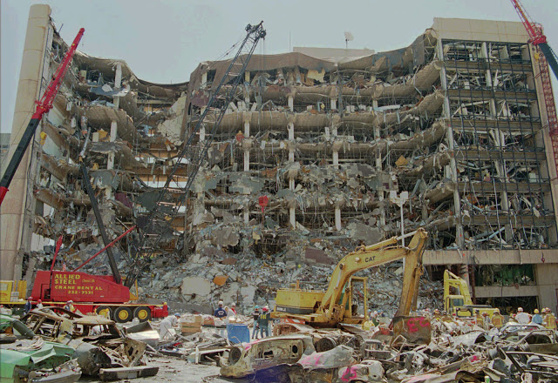
Discussion of the specific motives of radical Islamist groups is off limits because it is taken as excusing terrorists. An odd position, when we consider our justice system. In murder trials, part of confirming guilt lies in establishing motive. Showing the motive of a murderer hardly excuses the crime. Motives may partially exonerate, but they can also suggest how despicable some crimes are. In any case, if our goal is safety rather than buttressing our own sense of righteousness, shouldn’t we want to know as much as possible about the criminal? To combat BP and Taliban crimes, we need to understand both the cultures of predatory capitalism and various radical religious sects both here and abroad. The concept of crime must be applied as carefully to corporate actions as to those of extremist religious sects. The Left must avoid a double standard. If we are willing, as we should be, to assess the motives and context of the Times Square bomber’s actions, we must adopt the same breadth in our examination of other Manhattan reprobates. There is little to admire in Lloyd Blankfein or BP’s CEO, but both are part of a corporate culture and worldview that idolizes wealth, has celebrated deregulation, disrespects government, regards fines for law violation as a cost of doing business, and places a premium on immediate rewards. That culture emerged amidst the crisis of liberalism a generation ago. Following the sharp run up in oil prices in the wake of the oil embargo and late seventies stagflation, Republicans ran on a plank of economic deregulation and bashing of government. Many Democrats followed close behind. Not surprisingly both regulation and regulators easily got a bad name.
More broadly, the sense of cheap oil as a right has become built into the culture and is part of the context in which BP operates. One former oil executive is not far from the mark in suggesting that one reason BP operates in deep water is that coastal residents abhor rigs but want the oil.Out of sight, out of mind.
Reluctance to deem BP a criminal or terrorist reflects a broad social dependence on cheap oil. It leads to unwillingness by large sectors of the public to acknowledge fully the multifaceted risks of oil dependence. The US lags the world in its response to global climate change. Guardian columnist George Monbiot points out that as the consensus among climate scientists grows, public skepticism gains ground.
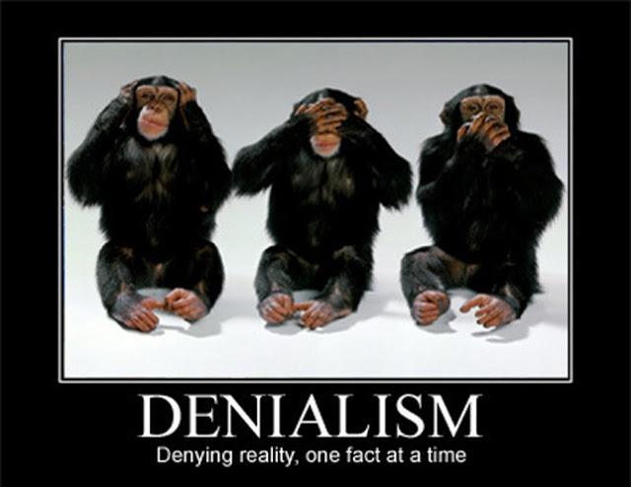
Natural science is unlikely to control the outcome of this argument. Social and religious values, even core sense of identity, play at least as big a role as the natural sciences. Consider environmentalists’ precautionary principle. Even if there is dispute as to the extent of man-made global warming, shouldn’t we err on the side of caution by reducing carbon emissions?
All of us, however, understand threats in terms of some fundamental set of core values. If one is convinced that free- market- driven growth can solve any problem, that government invariably screws up, and if one has a core sense that he or she is a strong, self-reliant being, then taxes or regulation involve disproportionate risk. The cautious course is not to intervene. As economic or environmental tragedy unfolds, many may cling all the more to the socially and economically conventional course. The Exxon Valdez brought us only double- hulled tankers to import even more oil safely.
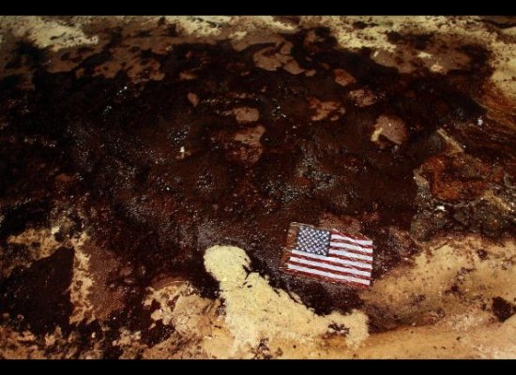
Greenhouse gas proposals could hardly come at a more difficult time. Working class Americans fear for their jobs, worry about immigrants and rapid cultural change, and are angry about Washington policies that bail out bankers. The white working class has a sense that little has been done for them for a generation. They rightly worry about who will bear the costs of new environmental initiatives.
For much of mainstream culture, a quasi-religious perspective is part of core attitudes on these issues. Following sociologist Ernest Becker, Monbiot suggests: “the fear of death drives us to protect ourselves with "vital lies" or "the armour of character". We defend ourselves from the ultimate terror by engaging in immortality projects, which boost our self-esteem and grant us meaning that extends beyond death. “
In the US, one popular immortality project has been a belief in a nature that can be fully understood in law-like terms and manipulated through free markets to serve growing individual prosperity. And both as symbol and contributor to that faith the auto has played a pre-eminent role, especially in a society that valorizes individual mobility.
This cultural and political background does not of course excuse BP of its responsibility to abide by accepted safety standards. Clear violations of law should be punished, but if our desire is to reduce corporate crime, we need to address the context in which both corporate and political terrorists or criminals regard themselves as above the law. In addition, we need to articulate positive alternatives to the culture of growth if environmentalists are to have much influence on a squeezed and insecure working class.
Today corporate crime and theoterrorism feed on each other. A rhetoric of international conspiracies undermining our freedoms strengthens the Cold War era national security state. That state has always fostered secretive dealings between government, the media, and supportive corporations. Corporations and governments have economic and political interests in pumping up the threat level. The atmosphere of imminent catastrophe creates a context in which CEOs and even substantial portions of the population can see corporations and political leaders as independent of any democratic political check and entitled to special support. This support in turn reinforces their power. A rhetoric of free markets and deregulation discourages public or worker checks on corporate power-- though not substantial government beneficence toward the most powerful corporate interests. A social conservative evangelical discourse adds support to a black and white worldview and demeans the most vulnerable citizens, often scapegoating them for economic troubles, thus sidelining economic reform. This self-reinforcing mix may make us less safe. Though a minority even among Muslim radicals, theoterrorists receive and enjoy disproportionate media focus on them. They use such attention—and the excesses to which Western democratic governments go—as an occasion to gain recruits.
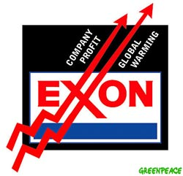
How would Americans feel if a foreign power, even one committed to uprooting acknowledged evil, frequently—albeit “accidentally”--killed thousands of civilians through high tech assassinations? These are the questions that a dogmatic faith in our own values, ways of life, and policies often excludes. If there is a way out, it may require a renewed emphasis on decent jobs and social justice. We must also strive for more attentiveness to the selective use of concepts of crime and terrorism. These foster and reflect racist and religious divisions that impede all reform efforts. We must also challenge our more is better mindset. Endless consumption may not be so much“human nature” as a process driven by corporate controlled information, status anxieties fed by inegalitarian workplaces, long and involuntary working hours for those lucky enough to have full time jobs, and the product choices of others. All of these are immunized from critique and reinforced by a countermodel portraying a group of radical terrorists out to undermine our freedoms. At the philosophical level, we might contemplate the possibility that nature itself is not designed to suit our purposes. Not only oil spills in deep and forbidding waters, but also volcanic eruptions and earthquakes may remind us that nature is not always fully predictable. But the nature that inflicts sporadic tragedy also gives us the unexpected splendor, from rainbows to the emergence of life itself. If we can reconcile ourselves to the possibility of untimely death and give ourselves more free time for interests and skills little developed, consider or reconsider what time with family and contemplation of our habitat brings us, we may develop more capacity to enjoy a pluralizing society and a pluripotential nature we need not conquer.

