EMA Scrapped!
EMA – Educational Maintenance allowance is no longer taking new applicants, those already receiving EMA will continue to do so for the rest of the academic year (2010/2011). EMA was (10-30 a week)
"With the rise in tuition fees making university seem out of reach, it's dispiriting that the Government doesn't even care that we have the ability to stay in education to 18.
"We all deserve a chance to stay in school and go to university."
Justin Khan, also at Cambridge, said: "Scrapping the EMA will be a catastrophe not only for sixth-formers, but for equality in this country.
"This goes hand in hand with the ideological public sector cuts where the Government has decided to make the public pay for a crisis caused by banks and corporations.

"The resistance from students over tuition fees and the EMA is only the beginning of the kind of resistance the Government can expect if it continues with its plans."

Students in sixth forms and colleges across England are expected to hold demonstrations against the abolition of the EMA tomorrow and a lobby in the House of Commons is planned.
"EMA is a hugely expensive programme, costing over £560 million a year." Department of Education
EMA teenagers from two London colleges will also take part in specially-arranged lessons at Parliament during the morning.
Union leaders said studies have shown that the EMA is a key factor in improving participation in further education.
Colleges in some of the most deprived areas will be hit hard if the EMA is scrapped. In some areas of Birmingham, Leicester and the North West as many as four-fifths of students receive the grant, they said.

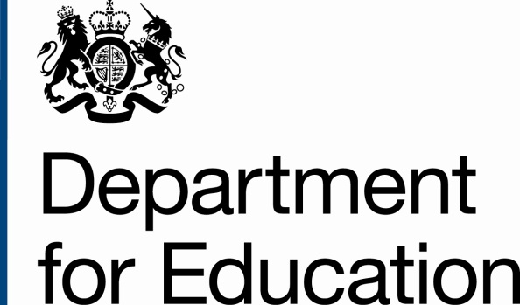
The Green Paper

Case for change
1. Every child deserves a fair start in life, with the very best opportunity to succeed. Currently, life chances for the approximately two million children and young people in England who are identified as having a special educational need (SEN), or who are disabled, are disproportionately poor.
2. Disabled children and children with SEN tell us that they can feel frustrated by a lack of the right help at school or from other services. For children with the most complex support needs, this can significantly affect their quality of life. Hundreds of thousands of families have a disabled child or a child with SEN, and parents say that the system is bureaucratic, bewildering and adversarial and that it does not sufficiently reflect the needs of their child and their family life.
3. Whilst the circumstances of children, young people and their parents differ greatly; from young people requiring a few adjustments in class to children with life-limiting long-term conditions, families have many shared concerns. The system to support children and young people who are disabled or who have SEN often works against the wishes of families. Children’s support needs can be identified late; families are made to put up with a culture of low expectations about what their child can achieve at school; parents don’t have good information about what they can expect and have limited choices about the best schools and care for their child; and families are forced to negotiate each bit of their support separately.
What are the different areas that have been looked at?

White Paper
- Review and reform the National Curriculum so that it becomes a benchmark outlining the knowledge and concepts pupils should be expected to master to take their place as educated members of society.
- Ensure that all children have the chance to follow an enriching curriculum by getting them reading early. That means supporting the teaching of systematic synthetic phonics and introducing a simple reading check at age six to guarantee that children have mastered the basic skills of early reading and also ensure we can identify those with learning difficulties.
- Hold an independent review of assessment at the end of primary school to improve the current system so that parents have the information they need and schools can be properly accountable without feeling that they must drill children for tests.
- Encourage schools to offer a broad set of academic subjects to age 16, by introducing the English Baccalaureate.
- Following Professor Alison Wolf’s review of vocational education, make necessary reforms so that vocational qualifications support progression to further and higher education and employment.
- Support more young people to continue in education or training to age 18.
- Obtain an honest view of our national performance by ensuring pupils take part in international tests of literacy, mathematics and science.
- Ask Ofqual to measure qualifications against the best in the world so that, at age 16 and beyond, students are able to choose from a range of high-quality and rigorous qualifications respected and valued by universities and employers.

White Paper - Free schools
We too want to support teachers, charities, parent groups, faith organisations and others who have the vision, drive and skills to set up a new school – and to give them the freedoms to try out new approaches and make a real difference in their communities.
In June 2010, we invited Free School applications of any type or phase (including special schools, alternative provision and 16–19 proposals) from teachers, charities, parents and others. Free Schools will be independent state schools which benefit from all the same freedoms and autonomy as Academies. Over 180 people and organisations have already submitted proposals and so far 25 Free School projects are in the formal business case and planning stage and some will be open as early as September 2011⁸⁸. The projects range from an outstanding young teacher, Sajid Hussein, who has plans to open King’s Science Academy in a poor area of Bradford, to the Stour Valley Community School in Suffolk, which is an example of a community coming together to open the secondary school it wants, and Cuckoo Hall, an outstanding primary school in Enfield, proposing to open a new school.
White paper - School funding

We will:
- Target more resources on deprived pupils over the next four years, through a new ‘Pupil Premium’: extra money for each deprived pupil. We will be spending £2.5 billion per year on the Pupil Premium by the end of the Spending Review period.
- Consult on developing and introducing a clear, transparent and fairer national funding formula based on the needs of pupils, to work alongside the Pupil Premium.
- In the meantime, increase the transparency of the current funding system by showing both how much money schools receive on a school-by-school basis and how they spend their funds.
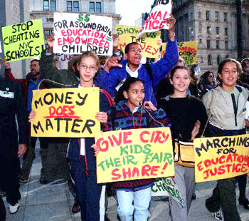
- End the disparity in funding for 16–18 year-olds, so that schools and colleges are funded at the same levels as one another, and at the levels of the most efficient.
- Devolve the maximum amount of funding to schools, making information and tools available to governors and head teachers which will support them in making good spending decisions.

Education (Primary/secondary) Reform Bill 2011

School League Tables
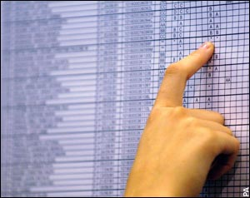
- (a) School League tables in their current form are to be scrapped and replaced with ones based on Marks given by Ofsted.
- (i) The present school inspections are to be reverted to the previous framework, but will still remain.
- (b) Every year Ofsted must inspect each school for a period of at least 3 days once every year. During this period Ofsted are to mark each school on a number of areas, each area will have 100 marks.
- (i) The areas are as follows:
- * Teaching Ability
- * Standards of Attainment
- * Standards of Facility
- * Pupils Behaviour and the Schools control of that
- * The Schools ability to contact parents and guardians about their son/daughters progress.
- (c) The Department for Education is to give funding based on how each school does in the marks.
- (i) The DfE are to fund each school on a decreasing scale from the bottom schools up - meaning that the schools that do poorly get extra funding to try and make them better.

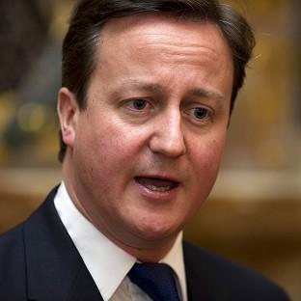
New Right
Choice: This is achieved in a variety of ways: by encouraging different types of school; allowing businesses a say in the building, ownership and running of state schools; encouraging fee-paying, private, schools (thereby contributing to the diversity of educational provision and the enhancing of parental choice).
Parents should be free to choose the school they want their children to attend – whether this is State maintained or private. The basic model here is a business one – just like with any business, those that offer the customer good value will thrive and those that offer poor value will fold. When parents exercise choice “good” schools will expand to accommodate all those who want a place and “bad” schools will close as their numbers decline.

